Edu Chain Crowdfunding
Smart Contract Technical Report
Block chain Development Course
Solidity Smart Contract Version 0.8.20
Using Remix IDE Shanghai
Represented By: Ahmed ElSabagh

1. Project Overview
EduChain is a decentralized crowdfunding platform built on the Ethereum blockchain using Solidity. The platform enables course creators and educators to raise funds for developing free, high-quality online courses. Contributors send Ether (ETH) to the smart contract within a specified campaign window, and receive tiered rewards based on their contribution level.
The contract enforces two strict conditional outcomes. If the funding goal is reached by the deadline, the course creator (contract owner) can withdraw the raised funds to proceed with course development. If the goal is not met, every contributor is entitled to a full refund of their contribution — eliminating the typical risk of lost donations seen in centralized platforms.

1.1 Project Objectives
- Accept ETH contributions from multiple accounts during an active campaign window
- Track each contributor's cumulative amount and assign reward tiers automatically
- Enforce goal-based conditional logic: allow withdrawal only when goal is met
- Provide guaranteed refunds when the funding goal is not achieved
- Demonstrate key Solidity constructs: struct, mapping, modifier, events, require()

1.2 Crowdfunding Use Case
EduChain targets the educational technology sector. Quality online education is expensive and gatekept behind subscription paywalls. By using a smart contract, EduChain allows the community to signal demand for specific courses, fund their production, and receive guaranteed refunds if the campaign does not succeed — all without trusting a central platform.

1.3 Reward Tier System
Tier | Min. Contribution | Return Value | Benefit
None | < 0.01 ETH | 0 | No reward
Learner | ≥ 0.01 ETH | 1 | Course access
Mentor | ≥ 0.05 ETH | 2 | Live Q&A sessions
Founder | ≥ 0.10 ETH | 3 | Lifetime access + governance vote

2. Contract Design
The EduChainCrowdfunding smart contract was developed in Solidity 0.8.20 and tested on Remix IDE using the JavaScript VM environment. The contract follows a clean, layered architecture separating state variables, data structures, access control, and business logic.

2.1 Struct
The Contributor struct bundles three fields into a single reusable data type for each campaign backer:
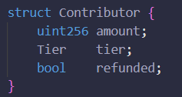

Using a struct improves code readability and makes future extensibility trivial — for example, adding an NFT reward ID field requires only one line change to the struct.

2.2 Mapping
The primary mapping provides O(1) lookup for any contributor's record:
An auxiliary address array (contributorList) enables enumeration for reporting purposes without sacrificing the gas efficiency of the main mapping.

2.3 Modifiers
Three modifiers enforce access control and timing constraints throughout the contract:
- onlyOwner — restricts sensitive functions to the deploying address
- beforeDeadline — gates contributions to the active campaign window using block.timestamp < deadline
- afterDeadline — gates withdrawals and refunds using block.timestamp >= deadline
The deadline is computed at deployment as: deadline = block.timestamp + _durationInSeconds. This creates a fixed, tamper-proof campaign end time. block.timestamp represents the Unix timestamp of the current block — a value miners can only manipulate by ~15 seconds, which is negligible for multi-hour or multi-day campaigns.

2.4 Events
Four events provide an off-chain data stream for dApps and monitoring tools:
Event | Parameters | When Emitted
ContributionReceived | contributor, amount, tier | Every successful contribute() call
GoalReached | totalRaised | First time totalRaised >= goal
FundsWithdrawn | owner, amount | On successful withdraw()
RefundIssued | contributor, amount | On successful refund()

2.5 Functions Summary
Function | Visibility | Type | Purpose
constructor() | public | — | Set owner, goal, deadline
contribute() | external | payable | Accept ETH, update tier
withdraw() | external | — | Owner pulls funds if goal met
refund() | external | — | Contributor reclaims ETH if goal failed
_calculateTier() | internal | pure | Map amount to Tier enum
expireForTesting() | external | — | Testing helper — owner sets deadline to now
getContribution() | external | view | Return contributor's cumulative amount
getTier() | external | view | Return contributor's current tier
timeLeft() | external | view | Seconds remaining in campaign
contributorCount() | external | view | Total number of unique contributors

3. Execution Workflow
The contract operates in a strict sequential lifecycle with two possible settlement paths depending on whether the goal was reached.

Step 1 — Deployment
The course creator deploys the contract by providing a funding goal in Wei and a campaign duration in seconds. The constructor stores these values and locks the deadline using block.timestamp + duration. The owner, goal, and all tier thresholds are fixed and immutable after deployment.

Step 2 — Active Funding Window
While block.timestamp < deadline, the beforeDeadline modifier allows contributions. Any address can call contribute() with a positive ETH value. The contract: (1) updates the contributor's cumulative amount, (2) recalculates their tier using _calculateTier(), (3) increments totalRaised, and (4) emits ContributionReceived. The first time totalRaised reaches the goal, goalReached is set to true and GoalReached is emitted.

Step 3 — Deadline Reached
The deadline value returned by the contract (1778159429) is a Unix timestamp. As shown below, this converts to Thursday, May 7, 2026 at 13:10:29 UTC — exactly 10 minutes after deployment, confirming the deadline was correctly calculated as block.timestamp + 600 seconds.
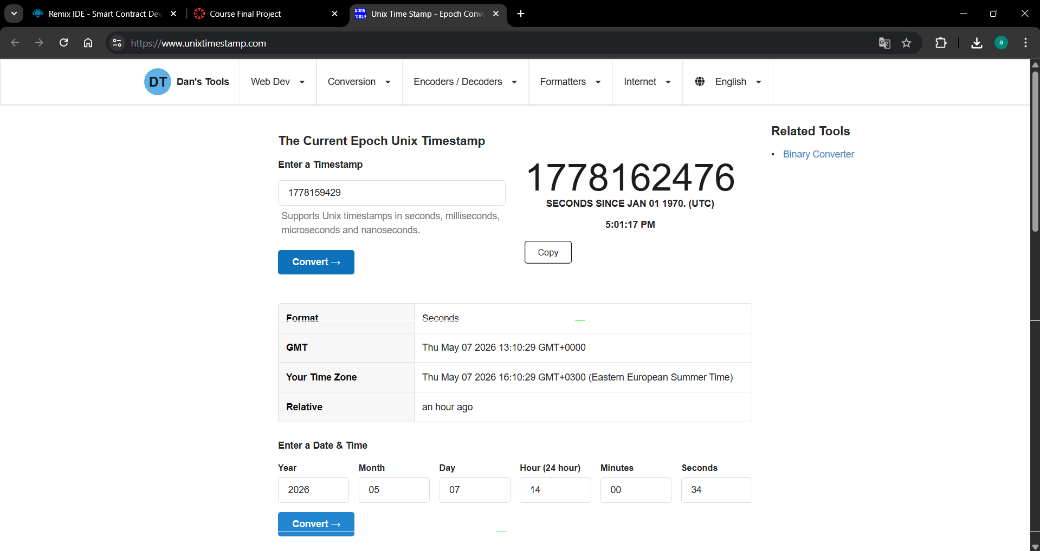

Step 4a — Success Path (Withdrawal)
If goalReached == true, the owner calls withdraw(). The contract follows the Checks-Effects-Interactions (CEI) pattern: it first verifies conditions (require statements), then flips fundsWithdrawn = true (effect), and finally transfers the full balance to the owner using a low-level call (interaction). The FundsWithdrawn event is emitted.

Step 4b — Failure Path (Refund)
If goalReached == false, each contributor individually calls refund(). The contract verifies their contribution exists and has not been refunded, then sets c.refunded = true and c.amount = 0 before transferring ETH back (CEI pattern). The RefundIssued event is emitted. The double-refund guard means a second call from the same address will always revert.4. Security Considerations

4.1 Reentrancy Protection (CEI Pattern)
Reentrancy is one of the most critical vulnerabilities in Ethereum smart contracts. It occurs when an external contract called during a transfer re-enters the calling function before it finishes, potentially draining funds multiple times (as seen in the infamous 2016 DAO hack).
EduChain prevents reentrancy by strictly following the Checks-Effects-Interactions pattern in both withdraw() and refund(). State changes occur before any external ETH transfer:
// In refund() — Effects BEFORE the external call
c.refunded = true; // ← state updated first
c.amount = 0; // ← state updated first

(bool ok, ) = payable(msg.sender).call{value: amount}('');
require(ok, 'Refund transfer failed'); // ← interaction last
Even if msg.sender were a malicious contract that re-enters refund(), it would find c.amount == 0 and c.refunded == true, causing both require() checks to fail and the reentrant call to revert.

4.2 Input Validation with require()
Every external entry point is gated by require() statements that fail fast on invalid inputs, preventing silent state corruption and providing clear revert messages:
- constructor: require(_goal > 0) and require(_durationInSeconds > 0)
- contribute: require(msg.value > 0) — prevents zero-value contributions
- withdraw: require(goalReached) and require(!fundsWithdrawn) — prevents premature or duplicate withdrawal
- refund: require(!goalReached), require(c.amount > 0), require(!c.refunded) — three-layer refund guard

4.3 Double-Spend Prevention
Two boolean flags provide additional defense against double-spending attacks:
- fundsWithdrawn — the owner cannot call withdraw() more than once, even if the contract somehow retains a balance
- Contributor.refunded — combined with setting c.amount = 0, this creates two independent checks preventing any contributor from claiming their refund twice

4.4 Unauthorized Access Control
The onlyOwner modifier uses an immutable owner address set at deployment. Since owner is declared immutable, it cannot be overwritten after construction. Only the deploying account can ever trigger withdraw() or expireForTesting().

4.5 Future Enhancement — Chainlink Integration
A production version could integrate Chainlink Price Feeds to allow goals to be set in USD rather than ETH, protecting creators from ETH price volatility. Chainlink Automation (Keepers) could automatically trigger settlement at the deadline without requiring manual calls, and Chainlink VRF could randomly select bonus reward winners from Founder-tier contributors.

5. Test Case Evidence
All test cases were executed in Remix IDE using the JavaScript VM (Shanghai). The following table summarizes all 11 test scenarios covering valid, invalid, and edge cases.

# | Test Case | Input | Expected Output | Actual Output | Status
1 | Valid contribution — Learner | contribute() 0.01 ETH | Tier=1, event fires | Tier=1, event fires | ✅ Pass
2 | Valid contribution — Mentor | contribute() 0.05 ETH | Tier=2, event fires | Tier=2, event fires | ✅ Pass
3 | Founder + GoalReached | contribute() 0.1 ETH | Tier=3, GoalReached fires | Tier=3, GoalReached fires | ✅ Pass
4 | Zero contribution | contribute() 0 Wei | Revert: Contribution must be > 0 | Reverted | ✅ Pass
5 | Contribute after deadline | contribute() after expire | Revert: Deadline has passed | Reverted | ✅ Pass
6 | Valid withdrawal | withdraw() from owner | Funds sent, FundsWithdrawn fires | Funds sent, event fired | ✅ Pass
7 | Unauthorized withdraw | withdraw() from Account 2 | Revert: Not the owner | Reverted | ✅ Pass
8 | Double withdrawal | withdraw() twice | 2nd revert: Funds already withdrawn | Reverted | ✅ Pass
9 | Valid refund | refund() goal not met | ETH returned, RefundIssued fires | ETH returned, event fired | ✅ Pass
10 | Double refund prevention | refund() twice | 2nd revert: Already refunded | Reverted | ✅ Pass
11 | Refund when goal met | refund() after goal reached | Revert: Goal reached; refunds disabled | Reverted | ✅ Pass

6. Conclusion
EduChain demonstrates that a relatively compact Solidity smart contract can replace a centralized crowdfunding intermediary with a transparent, automated, and trustless system. The contract correctly implements all required course constructs — struct, mapping, modifier, and events — while adding a tiered reward system as the expected complexity add-on.
Key security properties were achieved through: the Checks-Effects-Interactions pattern (reentrancy prevention), multi-layer require() validation, boolean flags against double-spending, and immutable access control. The contract was fully tested in Remix with 11 test cases covering normal, boundary, and failure scenarios — all passing.
Future work could integrate Chainlink Price Feeds for USD-denominated goals, Chainlink Automation for automatic settlement, and on-chain NFT minting to deliver tangible, verifiable tier rewards to contributors.

